**Project Report**

**On**

**GPS Toll based System simulation using Python**

**Student**

**Sravani S**

**College Mentor**

**Dr Harshada J Patil**

**Vemana institute of technology, Bangalore**

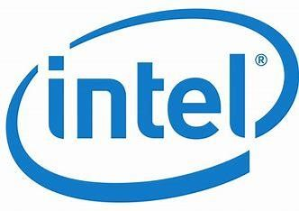

**Table of contents**

|  |
| --- |
| Objective |
| View of project |
| Flowchart of AI food recipe |
| My own idea about this project |
| Imaginary block diagram. |
| Conclusion |
| Future scope |

**Objective**

To customize AI kitchen for india.

To reduce cooking time .

To have more applications in less area.

To maintain automatic cleanliness and fragrance.

To give a more brief design soo that. utilization of kichen space will be done fully.

**View of project**

The project is about to customize AI kichen for India.It can generate new version of modern kichen .It can give more idea to utilize space properly and use for various applications.It can help for people those who do not know to cool by displaying the chart of ingredients or the flow chart to follow the process along with quantity.It can used to escape from fire accidents.A new version of dirt absorbing technology can be created.

**Flowchart of AI food recipe**

**Fig:1**

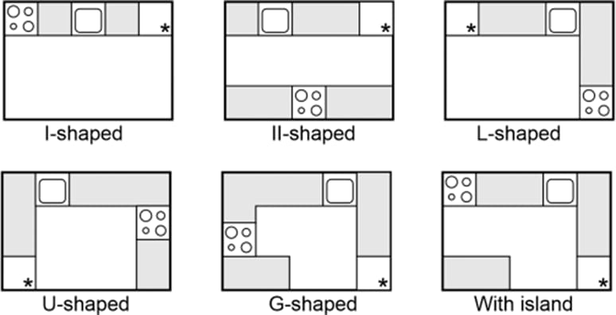

**Fig:2**

**My own idea about this project**

This idea is to reduce space for various items. In kitchen we use different items which require different temperatures so we use different equipments like refrigerator, oven etcc..which can consume more area of kitchen ..which can be utilized for some otter purpose .soo my point of imaginary block diagram is given below .Here 3 compartments are used which should be maintained at 3 different temperatures which should be fixed to wall.

**Imaginary block diagram**

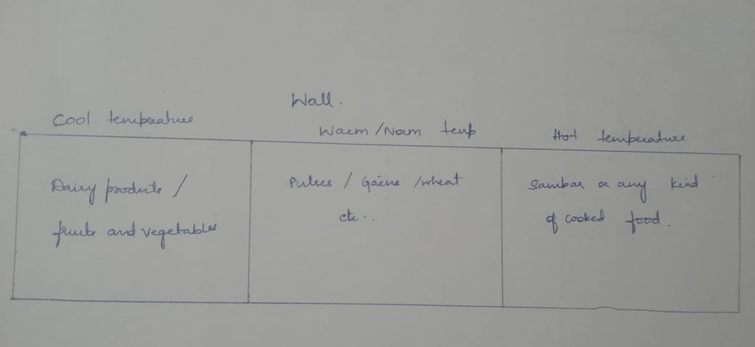

**Problem faced**

The main problem faced is we will require to design equipments using micro elements or small chips and IC .which require expertise in that areas.

**Conclusion**

Nowadays, a smart home or kitchen is common. But after the booming field of AI, we understand that if we add AI to our kitchen automation field, we can benefit more from the technology. So here we demonstrate how we can build our AI-enabled AI kitchen with the help of the latest technology in the AI field